**Vinay Dhanraj**

**151098**

**PJM530**

**Using Microsoft Project do the following project schedule and then answer the questions that follow**

* Create a project for developing a website with the following phases
  + Requirements
  + Analysis
  + Development
  + Testing
* Onboard your team
  + Messi (BA) Rate 100 $/hr
  + Rocky (Dev) Rate 125 $/hr + Overtime rate 150$/hr
  + Kate (QA) Rate 80 $/hr
* Create two tasks under each phase and assign resources appropriately
  + For requirements
    - BRD Authoring (Messi – 100%) – 2 weeks
    - BRD Review (Messi – 50%, Rocky 50%) – 3 days
  + Analysis
    - FSD authoring (Messi – 100%) – 2 weeks
    - FSD Review (Messi – 50%, Rocky 50%) – 5 days
  + Development
    - Developing the website (Rocky 100%, Messi 25%) – 5 weeks
    - Unit Testing (Rocky 100%, Messi 25%) – 2 weeks
  + Testing
    - Test case authoring (Kate 100%) – 1 week
    - Test case execution (Kate 75%, Messi 25%, Rocky 75%) – 4 weeks
* Dependencies
  + BRD Review can start half way when Authoring is done
  + FSD Authoring can start in paralles to BRD review
  + Development has to start after analysis is completed
  + Test case authoring can start after BRD review is completed
  + Test case execution has to start after unit testing is completed

Demonstrate the following

1. Develop the project schedule showing dependencies

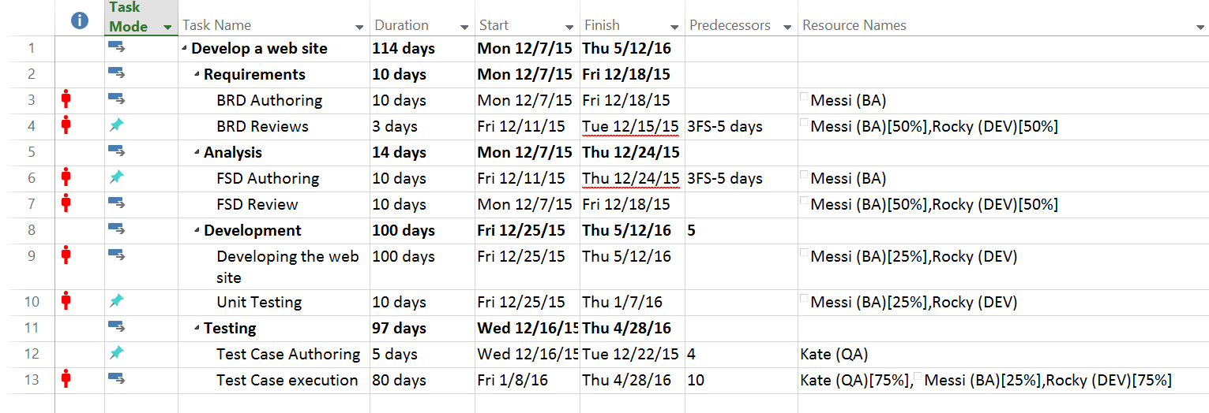

1. Gantt Chart

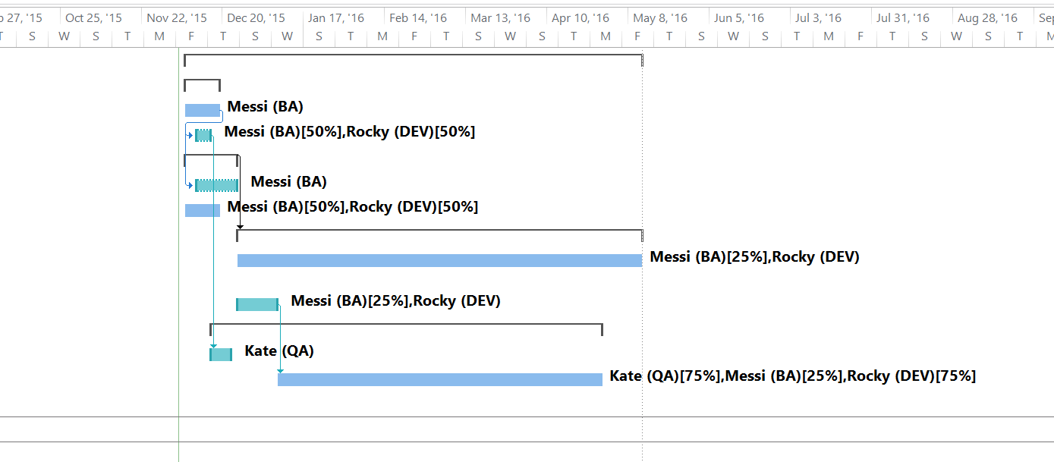

1. Critical path

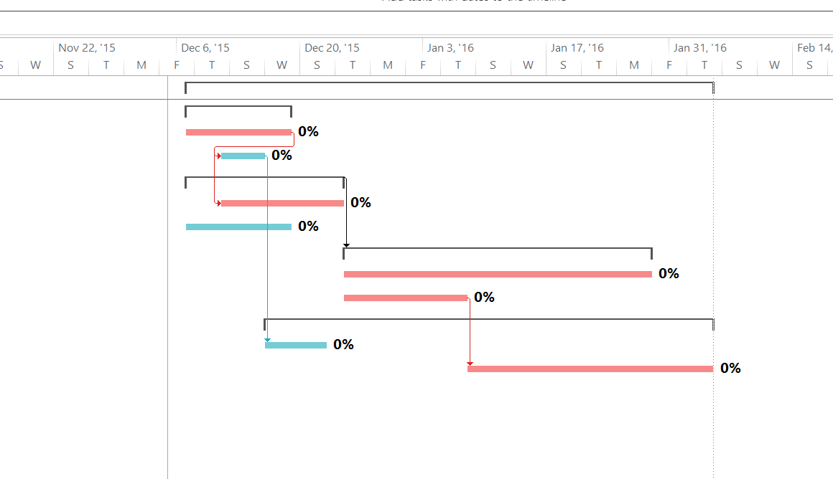

1. Resource Leveling

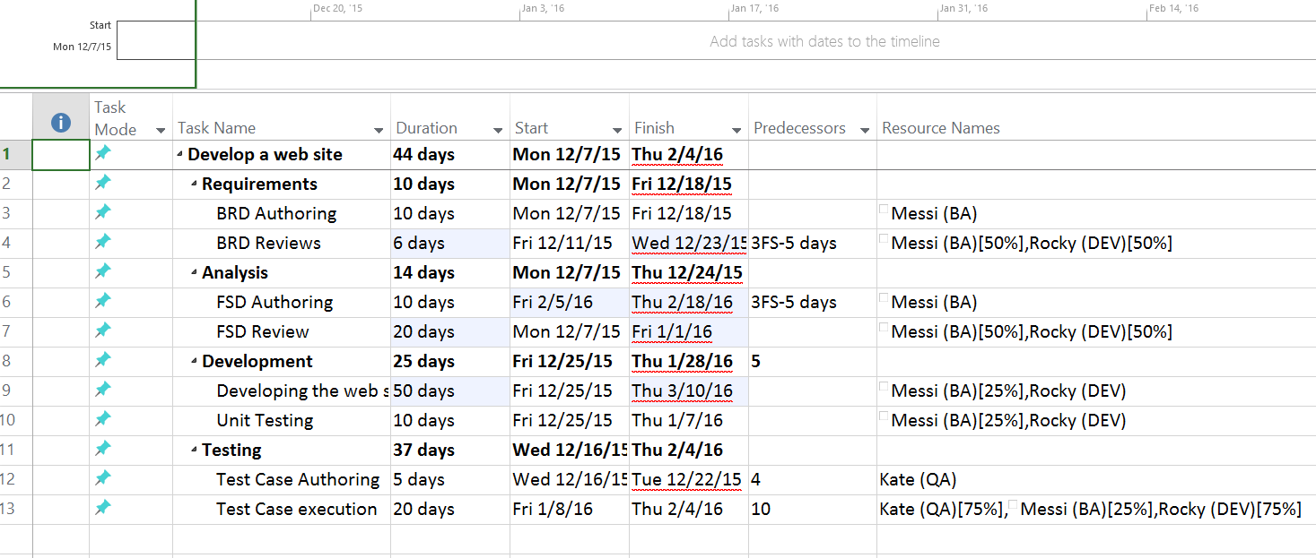

1. Setting project baseline

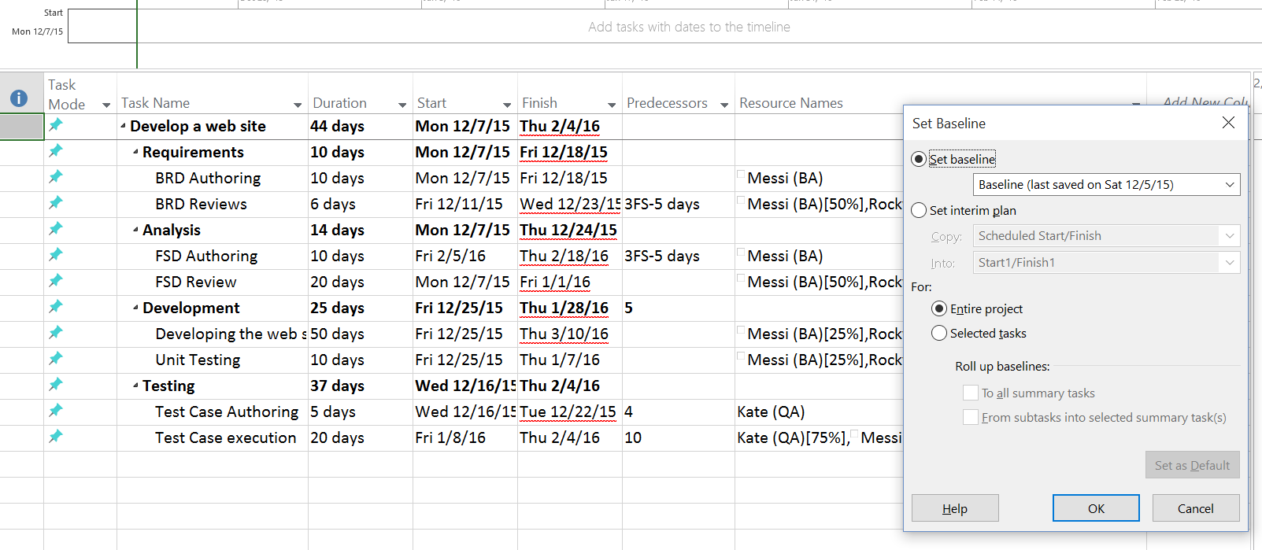

1. Earned value cost indicators

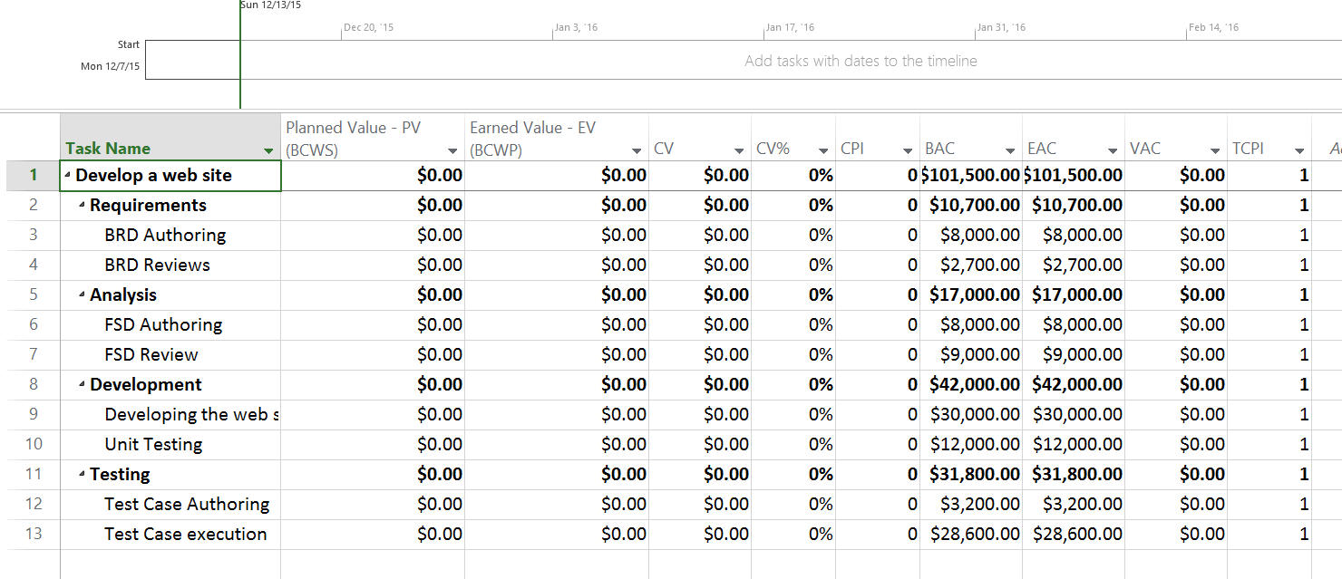

1. Earned value schedule indicators

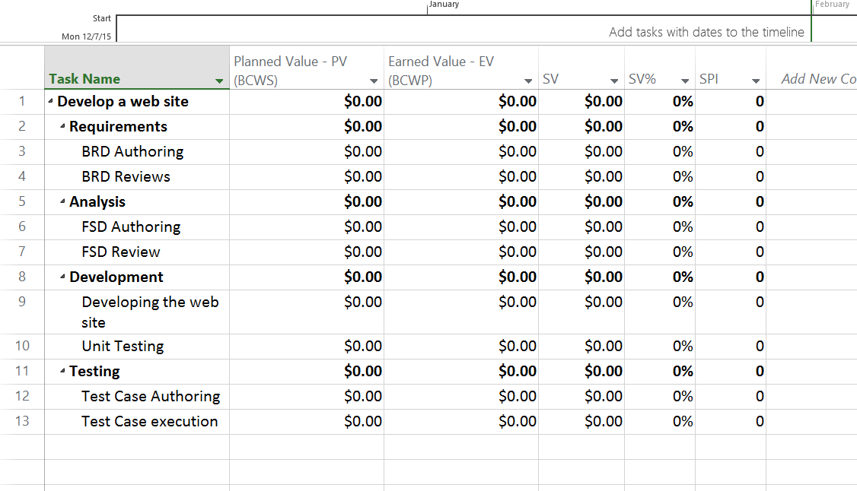

1. Showing slack in the Gantt chart

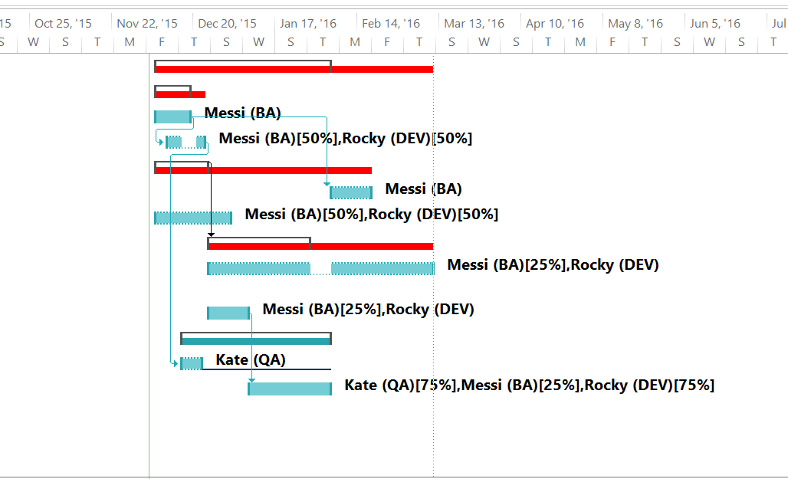

1. Add a milestone

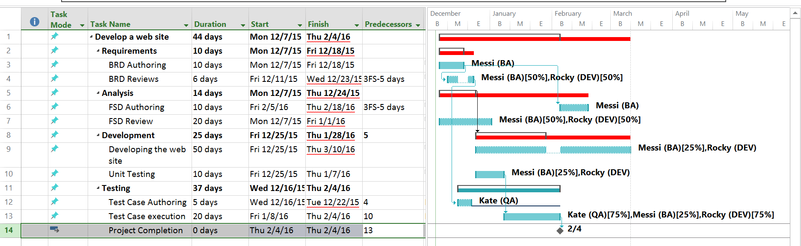

1. Demonstrate a custom report to show resource usage (optional)

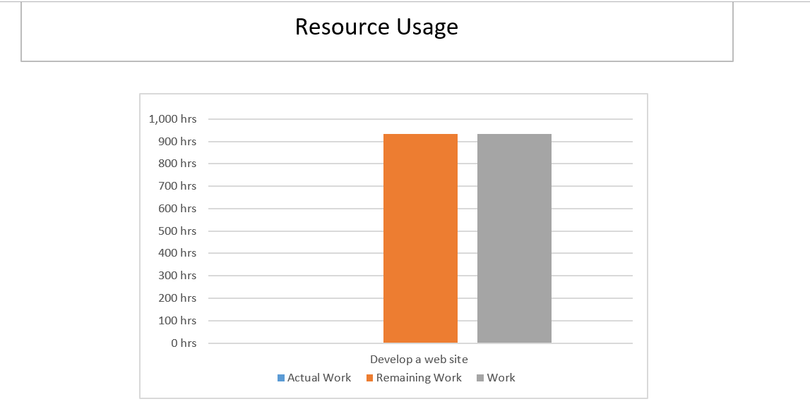

1. Timeline to copy into a presentation

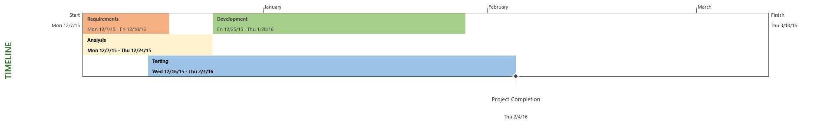

1. Calculate Budget

